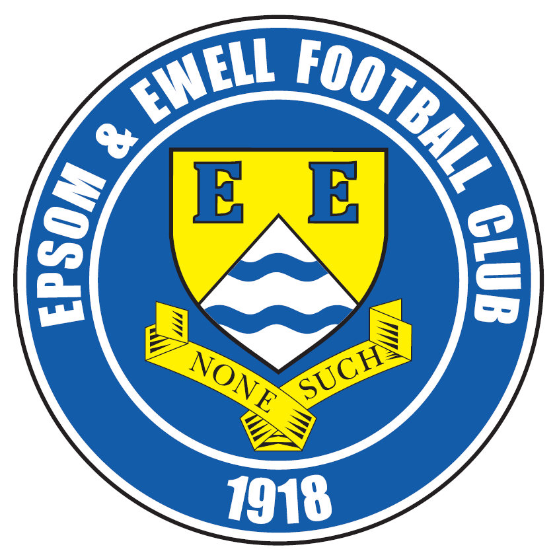 | Epsom & Ewell F.C.  10  v  Abbey Rangers / Windsor  Sunday, 13th November 2016 – 3.00 p.m.  Tuesday, 15th November 2016 – 7.45 p.m.
This programme is a joint issue so it’s either good afternoon or good evening depending on which match you are watching!

We welcome the players, officials and supporters of both Abbey Rangers and Windsor. Abbey have of course already been here twice this season in League and then League Cup action and we still have a trip there to arrange. That match was originally due for Saturday 3rd December but whoever wins this Buildbase F.A. Vase match will be in action in the Third Round on that date so it looks like a midweek trip in the New Year will be planned shortly.

Assuming that the match with Abbey hasn’t ended in a draw, we host Windsor here on the Tuesday evening, well aware by then of the draw for the next round and hoping we are still in it! Home matches have been few and far between recently with only one since the 24th September and that was only due to receiving a home draw in the previous round of the Vase. We are catching up now!

We were in action here on Tuesday when we defeated Sutton Common Rovers 2-1 thanks to goals from Jordan Gallagher and Matt Tanton. It was a close match but there was a period in the second half when we were well on top and for me that was enough to say we deserved the points. It was our ninth straight win over them and our 200th in the Combined Counties League. Not bad for just over ten years!

We are at home once again this coming Saturday with Bedfont Sports the visitors and AFC Hayes visit us seven days later. We are in need of match sponsors for these upcoming matches, so please let us know if you can help. At £55 which includes three free entries, programmes and hospitality it’s not a bad deal by any means, so please help your local club by speaking to a Committee Member.

All that remains to be said is that the Vase match would go to extra time if we are level after 90 minutes and if still undecided then we will go there for the replay on Wednesday 16th November.

Enjoy the game!

Rich

You can follow us on Facebook: www.facebook.com/epsomandewellfc Twitter: @EEFCOfficial and
Instagram at: www.instagram.com/epsomandewellfc We also have a Youtube channel now!

Cover photo by Gemma Jarman

Rob Hendry puts us ahead in our 2-0 win at Guildford on Saturday


Cherry Red Records Combined Counties League
Premier Division Table 2016/17
incl Wednesday 9th November | P | W | D | L | F | A | Pts | GD | H | A
Hartley Wintney | 19 | 16 | 2 | 1 | 70 | 19 | 50 | +51 | 18/3 | 10/12
Westfield | 17 | 11 | 4 | 2 | 37 | 15 | 37 | +22 | 18/2 | 1-2
Hanworth Villa | 18 | 10 | 3 | 5 | 29 | 24 | 33 | +5 | 13/12 | 14/1
Knaphill | 19 | 10 | 2 | 7 | 41 | 34 | 32 | +7 | 4-0 | 8/4
Guildford City | 19 | 9 | 4 | 6 | 46 | 38 | 31 | +8 | 17/1 | 2-0
Walton & Hersham | 15 | 8 | 5 | 2 | 23 | 13 | 29 | +10 | 4/3 | 1-1
Bedfont Sports | 16 | 9 | 2 | 5 | 34 | 30 | 29 | +4 | 19/11 | 7/2
Epsom & Ewell | 16 | 8 | 3 | 5 | 39 | 24 | 27 | +15 | X | X
Camberley Town | 16 | 8 | 2 | 6 | 33 | 18 | 26 | +15 | 0-0 | 1/4
CB Hounslow United | 15 | 8 | 1 | 6 | 30 | 27 | 25 | +3 | 1-5 | 12/11
Horley Town | 14 | 7 | 3 | 4 | 28 | 22 | 24 | +6 | 3-0 | 17/4
Windsor | 18 | 6 | 5 | 7 | 32 | 32 | 23 | 0 | 15/11 | 1-2
Colliers Wood Utd | 18 | 6 | 5 | 7 | 32 | 33 | 23 | -1 | 14/4 | 0-5
Abbey Rangers | 18 | 6 | 3 | 9 | 26 | 35 | 21 | -9 | 7-1 | 3/12
Spelthorne Sports | 16 | 5 | 5 | 6 | 27 | 26 | 20 | +1 | 7/1 | 25/2
North Greenford Utd | 15 | 5 | 4 | 6 | 31 | 29 | 19 | +2 | 22/4 | 1-2
AFC Hayes | 16 | 5 | 2 | 9 | 22 | 29 | 17 | -7 | 26/11 | 28/1
Farnham Town | 16 | 5 | 1 | 10 | 25 | 37 | 16 | -12 | 25/3 | 2-1
Raynes Park Vale | 19 | 4 | 4 | 11 | 25 | 40 | 16 | -15 | 27/12 | 1-1
Sutton Common Rvrs | 16 | 4 | 3 | 9 | 18 | 30 | 15 | -12 | 2-1 | 2/1
Chertsey Town | 16 | 4 | 2 | 10 | 15 | 42 | 14 | -27 | 17/12 | 11/2
Badshot Lea | 17 | 3 | 1 | 13 | 20 | 52 | 10 | -32 | 4/2 | 4-1
Bedfont & Feltham | 17 | 2 | 2 | 13 | 16 | 50 | 8 | -34 | 21/1 | 9-2

Club Manager – Glyn Mandeville
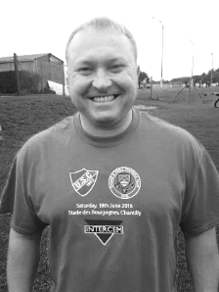
Hello and welcome to all from both Abbey Rangers and Windsor F.C. I hope you enjoy the game and I wish you all a safe trip home.

We go into these two matches knowing that we are playing quite well at the moment. When you look at the League table I believe that we should be higher than eighth, but the occasional mixed result has cost us. A late loss at North Greenford United was harsh, although we had a late goal at Raynes Park that earned us that point back. We have won our last two matches and hopefully there are more to come very shortly.

Tuesday’s match was a tough one as Sutton Common Rovers seem to up their game when they play us, but I thought we deserved the points in the end.

We were very short of players for the Raynes Park trip but we are currently free of suspensions and do not have too many injuries at present. We have also added Daniel Rose who I would like to welcome to the squad. He will be a useful addition.

Thanks to everyone for their continued support. I know the players appreciate it.

Manders

Lucky Day? – 13th November
Played 11 - W 5 D 3 L 3 - For 30 Against 24 - PPG 1.64 - Above Average
Our Club record against Abbey Rangers
Played 2 - W 2 D 0 L 0 - F 8 A 1 - PPG 3.00 - Perfect
Our Largest wins and losses against our opponent
23rd August 2016 - W 7-1 - Combined Counties League (H)
-
Their Last Visit
Tuesday 6th September 2016 - W 1-0 - Combined Counties League Cup 1

Lucky Day? – 15th November
Played 14 - W 4 D 0 L 10 - For 29 Against 46 - PPG 0.86 - Very Poor
Our Club record against Windsor
Played 48 - W 18 D 12 L 18 - F 88 A 90 - PPG 1.40 - Average
Our Largest wins and losses against our opponent
11th February 1984 - W 4-0 - Isthmian League Division One (H)
29th March 2003 - W 4-0 - Isthmian League Division One South (H)

15th August 1970 – L 0-6 - Athenian League Division Two (A)
Their Last Visit
Saturday 8th August 2015 - D 2-2 - Combined Counties League

Latest Results and Fixtures
Combined Counties League – Monday 7th November
Abbey Rangers | 3-3 | Knaphill
Combined Counties League – Tuesday 8th November
Camberley Town | 0-1 | Guildford City
Epsom & Ewell | 2-1 | Sutton Common Rovers
Combined Counties League – Wednesday 9th November
Colliers Wood United | 2-2 | Horley Town
Buildbase F.A. Vase – Second Round – Saturday 12th November
Highworth Town | V | Knaphill
Bedfont Sports | V | Haywards Heath Town
Camberley Town | V | Southall
Hartley Wintney | V | Melksham Town
Walton & Hersham | V | Glebe
Combined Counties League – Saturday 12th November
AFC Hayes | V | Colliers Wood United
Badshot Lea | V | Spelthorne Sports
Chertsey Town | V | Bedfont & Feltham
Farnham Town | V | Guildford City
Horley Town | V | North Greenford United
Raynes Park Vale | V | Westfield
Windsor | V | Hanworth Villa
Buildbase F.A. Vase – Second Round – Sunday 13th November
Epsom & Ewell | V | Abbey Rangers
Sutton Common Rovers | V | Sporting Club Thamesmead
Surrey Senior Cup Second Round – Tuesday 15th November
Ashford Town (Mx) | V | Knaphill
Combined Counties League Cup Third Round – Tuesday 15th November
Banstead Athletic | V | Westfield
Combined Counties League – Tuesday 15th November
AFC Hayes | V | Bedfont & Feltham
Epsom & Ewell | prov | Windsor
Hanworth Villa | prov | Camberley Town
Horley Town | V | Guildford City
North Greenford United | V | Badshot Lea
Walton & Hersham | prov | Raynes Park Vale
Latest Results and Fixtures
Combined Counties League Cup Second Round – Saturday 19th November
Worcester Park | V | Cove
Combined Counties League – Saturday 19th November
AFC Hayes | V | Hartley Wintney
Bedfont & Feltham | V | Walton & Hersham
Camberley Town | V | Raynes Park Vale
Chertsey Town | V | Windsor
Colliers Wood United | V | Badshot Lea
Epsom & Ewell | V | Bedfont Sports
Guildford City | V | CB Hounslow United
North Greenford United | V | Knaphill
Spelthorne Sports | V | Horley Town
Sutton Common Rovers | V | Farnham Town
Westfield | V | Abbey Rangers
Combined Counties League Cup Second Round – Monday 21st November
Sutton Common Rovers | V | Bedfont Sports
Combined Counties League Cup Third Round – Tuesday 22nd November
Farnham Town | V | Camberley Town
Combined Counties League – Tuesday 22nd November
CB Hounslow United | V | AFC Hayes
Westfield | V | Horley Town
Combined Counties League – Wednesday 23rd November
Guildford City | V | Colliers Wood United
Combined Counties League – Saturday 26th November
CB Hounslow United | V | Westfield
Chertsey Town | V | Bedfont Sports
Epsom & Ewell | V | AFC Hayes
Farnham Town | V | Badshot Lea
Hanworth Villa | V | Spelthorne Sports
Hartley Wintney | V | Guildford City
Horley Town | V | Camberley Town
Knaphill | V | Sutton Common Rovers
Raynes Park Vale | V | Abbey Rangers
Walton & Hersham | V | North Greenford United
Windsor | V | Colliers Wood United

From behind the goal
Epsom & Ewell 2-1 Sutton Common Rovers
Combined Counties League - Tuesday 8th November 2016

Tanton extends the run in a tight win over local rivals

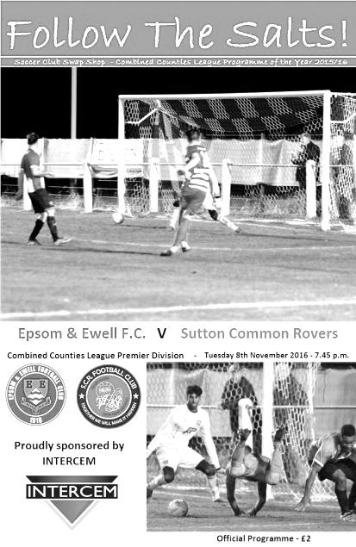
Matt Tanton's first goal of the season settled a battle between two closely matched teams at High Road on Tuesday evening, enabling us to record our ninth straight win over Sutton Common Rovers. Some might argue that the visitors were worth a draw over the ninety minutes, and we could not have complained that vociferously had this match finished level. However, much like last season's match here we had a really good period in the second half when we dominated proceedings for a while, and this proved to be the difference between the two teams. The win was also our 200th since rejoining the Combined Counties League in 2006.

Matches between ourselves and Sutton Common Rovers have often been fully committed and feisty affairs, but there was a little less of that last night. Both sets of players behaved fairly well, although much of this could have been a result of some odd and some downright mystifying decisions that probably left them as confused and frustrated as many of the spectators.

We made just the one change from our win at Guildford City as Dan Dean was held up at work and couldn't get to the ground in time. With James Taylor also working, this led to a bit of a rearrangement as Alex McKay dropped back into defence and Jordan Gallagher came into midfield. For the visitors it was good to see former Salt George Murphy back to fitness now and he was in their back four, while another former player Matt Robinson started on the bench.

On a typical chilly Chipstead evening the visitors had the better of the opening exchanges, forcing a number of free kicks although Michael Eacott dealt with the deliveries well. We had a set piece of our own in the 16th minute but Matt Ferdinando dragged his shot wide of Ollie Ellaway's right hand post. We had a nervous moment in the 21st minute when we didn't clear a corner very well and as the shot came in it was deflected and could have gone anywhere but fortunately it went straight into Eacott's hands.

At the other end we had a shout for a penalty when Ferdinando went for a long throw and was pushed over in the area. You don't often see them given but the push was quite a blatant one. A few minutes later we had a deep corner but as the ball dropped Craig Hastings went to meet but was unable to get a firm contact on the ball and Ellaway was able

to make the save.

In the 36th minute Danny Fernandez hit the joint of post and crossbar with a 25 yard free kick; the ball going out for a goal kick, but just as we did at Guildford we made the opposition pay for not taking their chances when we went ahead in the 42nd minute. A free kick was half cleared but the ball fell to Gallagher who hit a crisp shot low into the corner from the edge of the box.

With neither team looking particularly dangerous in the first half, taking these half chances are vital and it looked like we would push on from this but the visitors had other ideas and were level in the 48th minute when their left winger appeared to bundle Matt Farrell over, but play continued and his ball in was driven low past Eacott at the near post by Michael Campbell from about ten yards out.

The game was back in the balance and could have gone either way at this point but full credit goes to our boys who stepped up a gear and would boss the majority of the game from this point. The highlight of this was a well crafted goal in the 62nd minute. Rob Hendry made tracks down the left hand channel and clipped his ball in perfectly to Daryl Cooper-Smith who cushioned a header perfectly into Tanton's stride. He shrugged off the defensive challenge that came in and fired across Ellaway into the far corner. Matt only has one goal each season so far in his Salts career but they have all been great ones to watch!

Confidence began to flow and Hendry was just wide with an attempt from a Gallagher cross but we were beginning to stretch the opposition with a bit more width and Tanton produced another dangerous ball in. Clearly someone wasn't happy with the space our left back was creating and off the ball he took him out, leaving him in a heap on the floor but regrettably this wasn't seen by any of the officials and no action was taken. Still we continued to push, this time down the right where Ferdinando and Griffin combined for the latter to strike at goal but the ball was deflected wide for a corner. Shortly after this Gallagher cut in from the left and although his shot was blocked the ball fell to Ferdinando but his powerful strike was only just beyond the far post. He redeemed himself a few minutes later after Cooper-Smith set him up, but this time his fine effort was met by a brilliant one handed save by Ellaway, down to his left.

When Ferdinando then struck a free kick over the bar after a foul on Hendry it looked as though we were going to have to settle for a 2-1 win but the visitors maybe also sensed this and picked up their efforts to claim a point. The last five minutes were quite nervy for home supporters as we didn't look particularly comfortable in seeing the match out, even with Dean on the field by now for the injured Hendry. Our other substitute Jason Nwachukwu had made a run down the left but in losing possession they broke quickly and Campbell got down the right, cutting in and unleashing a great shot that hit our far post and then went out for a goal kick. It was a reminder that single goal wins will often involve nervy finishes and as we learned at North Greenford recently it can sometimes cost you dearly. Having said that, it is a positive sign that we are still finding ways to win these tight matches and we move up to eighth place in the league as a result.

Epsom and Ewell: Michael Eacott, Reisse Griffin, Matt Tanton, Craig Hastings, Alex McKay, Savvas 'Agi' Panayiotou, Jordan Gallagher, Matt Farrell (c), Daryl Cooper-Smith,
Rob Hendry, Matt Ferdinando
Subs: Jason Nwachukwu for Gallagher (80), Dan Dean for Hendry (86)

Club Records - 13th November
Date | Day | Competition |  | Opponents |  | Scorers
13/11/26 | Sat | Amateur Cup 3q | H | West Norwood | 2-1 | R.Marlow, W.Challis
13/11/37 | Sat | London League Cup 1 replay | A | Tilbury | 3-3+ | J.Jones (pen), T.Winship, D.Silbury
13/11/48 | Sat | London League | H | Bedford Town Reserves | 5-1 | E.Watkins (pen), F.Chitty, o.g., K.Minter, B.Cutter
13/11/54 | Sat | Corinthian League | H | Edgware Town | 4-5 | B.Musto (2), J.Crane (pen), B.Avis
13/11/65 | Sat | Surrey Senior Cup 2q | A | Merstham | 5-0 | P.Deadman (2), R.Barton D.Hollands, T.Wiltshire,
13/11/76 | Sat | Surrey Senior Cup 3q | A | Lion Sports | 3-1 | T.Tuite (2), G.O'Rourke
13/11/79 | Tue | Isthmian League 1 | A | Wembley | 0-0
13/11/82 | Sat | London Senior Cup 2q | A | Ruislip Manor | 4-3 | D.Barnard, S.Hill, S.Milton, K.Roots
13/11/01 | Tue | Isthmian League 3 | H | Witham Town | 1-1 | S.Hatton
13/11/04 | Sat | Isthmian League 2 | A | Enfield | 1-3 | R.Ingham
13/11/12 | Tue | Combined Counties  Premier Division | H | Croydon | 2-6 | A.McGregor, K.Hough
Historical Decades
90 years ago – Epsom Town F.C.
13/11/26 | Sat | Amateur Cup 3q | H | West Norwood | 2-1 | R.Marlow, W.Challis
80 years ago – Epsom F.C.
14/11/36 | Sat | Surrey Senior Cup 3q | H | Beddington Corner | 2-1 | J.Jones (pen), H.Pullen
70 years ago – Epsom F.C.
16/11/46 | Sat | London League | A | Woolwich Poly | 1-3 | G.Brogdale
60 years ago – Epsom F.C.
17/11/56 | Sat | Corinthian League | H | Erith & Belvedere | 8-1 | J.Bangs (4), D.Hermitage (2), J.Sorensen, B.Jenkins
50 years ago – Epsom & Ewell F.C.
12/11/66 | Sat | Athenian League 2 | H | Aveley | 4-2 | J.McNaught, T.Smith, T.Thomas (pen), T.Williams
40 years ago – Epsom & Ewell F.C.
13/11/76 | Sat | Surrey Senior Cup 3q | A | Lion Sports | 3-1 | T.Tuite (2), G.O'Rourke
30 years ago – Epsom & Ewell F.C.
15/11/86 | Sat | Isthmian League 1 | A | Billericay Town | 1-3 | R.Kidd
20 years ago – Epsom & Ewell F.C.
16/11/96 | Sat | Isthmian League 3 | A | Camberley Town | 2-2 | A.Boxall (2)
10 years ago – Epsom & Ewell F.C.
11/11/06 | Sat | Combined Counties  Premier Division | H | Cobham | 3-0 | S.Hatton (2), D.Ike

History Corner – 13th November
90 years ago today we hosted West Norwood in the Amateur Cup. This club had been at the forefront of Amateur football for many years, even playing our West Street forerunners Ewell F.C. in the 1890s. They were one of the first clubs to join the Isthmian League where they had competed at Amateur football’s top table for over a decade. However, times were hard for them and the loss of a ground would ensure a nomadic existence for nearly 20 years before finally folding in 1939. They were demoted from the Isthmian League in 1923 and by the time we met in 1926 they were an Athenian League club, but we still beat them 2-1 with goals from Reg Marlow, who was compiling a club record 65 goals that season, and Wilfred “Bronk” Challis, arguably the best left winger we ever had. The win earned us a home tie against Wimbledon in the final Qualifying round. More about that in a future issue.

79 years ago today we visited Tilbury for a London League Cup replay. Older supporters will remember regular visits to Tilbury’s St Chad’s Road ground where they still play, but prior to the war they played more or less across the road at the Orient Field. During this period both clubs won almost all their home games in the sequence so following a draw in the First Round we would have been concerned at replaying over there. However, we drew again 3-3 after extra time and by the time the second replay took place (winning 8-1!), it had held the competition up so much that it was continued into the following season with no new competition for 1938/39!

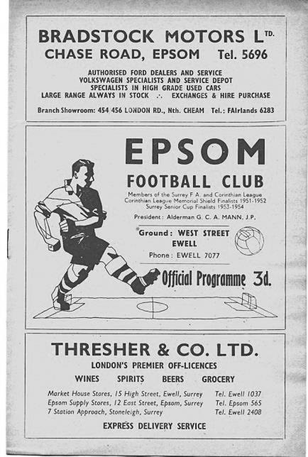
60 years ago this week we hosted Erith & Belvedere in a League match (see programme pictured) and destroyed them 8-1. The scorers were like a roll call of top local players as Johnny Bangs scored four times, Dave Hermitage scored twice and Jan Sorensen and Brian Jenkins got the others. We had a very good team this season but a disastrous final week ensured that we ended up with nothing!

51 years ago today we made our first ever visit to Merstham, who played in the same area as they do now, except that the pitch was switched 90 degrees back in the nineties to the view we recognise now. The small stand that is almost behind the goal at the far end was once the main stand, as the ground sat in the middle of a park. Back then of course no one had an inkling that we would be playing there ourselves for two seasons! Times have changed for the Moatsiders who are very much on the up these days, although instead of losing 5-0 to Oxford United as they did last weekend in the First Round of the F.A. Cup, it was a 5-0 win for our boys as we eased past the Surrey Senior League team, incidentally Managed at the time by the aforementioned Johnny Bangs!

34 years ago today we visited Ruislip Manor for a London Senior Cup tie. They were an Athenian League club so we were expected to progress, but it had been a tough first season under new Manager Adrian Hill and although the players were very good, it wasn’t quite happening that season and there were murmurs of relegation battles that fortunately never materialised. Not that I really understood this as a 15 year old enjoying the interest of away games in all these new places. As we cruised into a 3-0 half time lead there were no concerns but with two minutes remaining it was 3-3 and we required a late Steve Hill winner to get through in the end!

Abbey Rangers – History
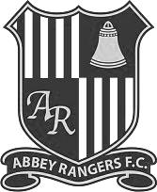
Abbey Rangers Football Club was formed in 1976 to initially promote and provide football for young boys between the ages of 6 through to 16 and taking its name from the historic Chertsey Abbey.

In the initial years Abbey Rangers had a rather nomadic existence having to use various home grounds within Chertsey and Addlestone but as the club grew in size it became clear that the club needed to plant its roots and were able to do so when we established a home on the old Meads school playing fields now known as Addlestone Moor. That ground now accommodates all formats of football from 5 v 5 up to adults.

After years of effort, the club opened up its new clubhouse in 2008, a superb and very welcoming facility partly funded by the Football Foundation. The facility was officially opened by Sir Trevor Brooking on 3rd June 2008.

The club has attained the FA Charter Community Status, and now have a healthy and growing girls and ladies section. The club also prides itself on being one of the leading lights in Surrey at providing disability football.

On the pitch, this team has made good progress over the years. After joining what is now known as the Guildford & Woking Alliance the club made big strides through the divisions and in 2008 we gained promotion to the Surrey County Intermediate League (Western) Division One winning the division at the first attempt and ensuring promotion to the Premier Division. We spent three seasons in the SCILW Premier Division finishing runners up in 2010-11 and 2011-12. After finishing runners up the 2nd time we took our place in the Surrey Elite League where we remained for three seasons finishing 5th, 3rd and 4th and winning the League cup in 2013-14.

The long term plan though for the club was always to reach the Combined Counties League and after extensive work and investment on the ground we were proud to finally be able to achieve that goal and take our place in 2015.

Our first season at this level has seen us make decent strides in the league but the clubs maiden foray in the FA Vase saw us cover some miles in reaching the 2nd Round Proper of that competition, the highlight being a 2-1 win at one of the pre-tournament favourites AFC Portchester. We finally succumbed to Wessex League Premier outfit Newport IOW in extra time.

Our league form improved and an unbeaten run that began at Christmas saw us finish in 3rd place and in doing so gaining promotion to the Combined Counties Premier Division at the first attempt.

This season saw another first for the club as we took our bow in the FA Cup, although it was all over very briefly as we lost 3-0 at Hellenic League Thame United.

Buildbase F.A. Vase
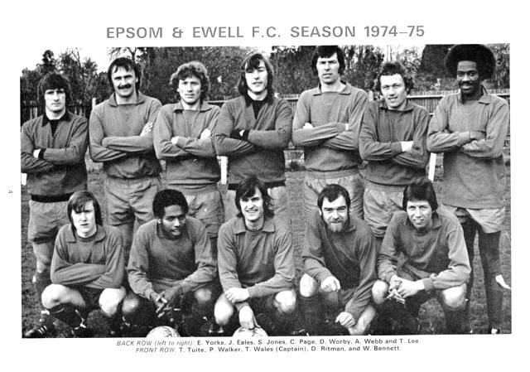

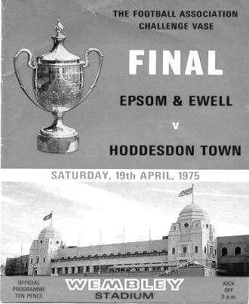
Second Round – Southern Clubs only – 36 of the 64 ties
Wadham Lodge | V | Ely City
Rothwell Corinthians | V | Tring Athletic
Leverstock Green | V | Welwyn Garden City
St Margaretsbury | V | Stanway Rovers
Newport Pagnell Town | V | Broadfields United
Berkhamsted | V | Hullbridge Sports
Gorleston | V | Northampton Sileby Rangers
Cockfosters | V | Wembley
Peterborough Sports | V | Biggleswade
London Colney | V | Holmer Green
Biggleswade United | V | Sun Sports
FC Romania | V | Ipswich Wanderers
Hoddesdon Town | V | Thetford Town
Basildon United | V | Felixstowe & Walton United
Eastbourne Town | V | Ashford United
Sutton Common Rovers | V | Sporting Club Thamesmead
Newhaven | V | Ascot United
Bedfont Sports | V | Haywards Heath Town
Eastbourne United | V | Crowborough Athletic
Walton & Hersham | V | Glebe
Camberley Town | V | Southall
Croydon | V | Andover Town
Corinthian | V | Alresford Town
Lancing | V | Horsham YMCA
Chichester City | V | Canterbury City
Highworth Town | V | Knaphill
Epsom & Ewell | V | Abbey Rangers
Portland United | V | Blackfield & Langley
Shaftesbury Town | V | Team Solent
Brimscombe & Thrupp | V | Bradford Town
Bristol Manor Farm | V | Odd Down
Moneyfields | V | Thatcham Town
Cullompton Rangers | V | Bemerton Heath Harlequins
Hartley Wintney | V | Melksham Town
Gillingham Town | V | Exmouth Town
Buckland Athletic | V | Newport (IW)

Windsor F.C. – History

Summer 2011 and it’s rather ironic that 100 years of senior football at Stag Meadow should be celebrated by the birth of a brand new club, Windsor FC, which came to be following the sad demise after 118 years of Windsor & Eton FC. During the final death throes of the previous club it became apparent, following several well attended supporters’ meetings, that the will was there to continue to host a senior football club in Windsor for the community to embrace and, therefore, on February 4th 2011 WFC Football Community Development Ltd was registered with Companies House with the aim of achieving that objective. Founding Director Kevin Stott and a newly-appointed management committee then set about the long and sometimes arduous task of turning that dream into a reality.

A business plan centred around self-sustainability was formulated and presented to the Football Association which eventually led to acceptance for the new club at level 5 of the non-league system and an allocation to compete in the Premier Division of the Cherry Red Records Combined Counties League for season 2011/12. Now the new club had been accepted it needed a name and invitations were extended to the people of Windsor to nominate and then vote on the new naming process and thus Windsor FC was born.

Self-sustaining and community are the two key elements behind the ethos of the new setup and the provision of a 3rd generation artificial surface training area/small-sided games pitches at the Great Park end of the ground, when completed, will form the foundations of the self-sustainability module as well as providing a much-needed facility for the community to use. The other main development thus far on the community side is welcoming on board the 34 teams and over 300 players of New Windsor Youth FC who will now be known as Windsor FC Youth, adopting the club badge and colours and providing a progression pathway from small-sided through to senior football for the youth of the town of Windsor.

One of our other innovative community involvement schemes sees our club mascot ‘Scotty the Stag’ regularly appearing at local school fetes and other events around the town publicising the club as well as supporting the fund raising activities of the club in general. In his spare time Scotty is becoming a bit of a celebrity taking part in races such as the Mascot Grand National and despite some close finishes is yet to claim his first win but if medals were given for effort then Scotty would be No.1 on the podium just for the amount of money he has raised for various local charities!

Our founding season turned out to be a very exciting one, eventually finishing as runners-up to worthy Champions Guildford City in the League. Several weeks into season 2012/13 a major decision to operate without a budget was taken to free up funds for the regeneration plans at the ground and the management team and all but three of the playing squad left immediately. Mick Woodham was appointed as our new manager and had two days to get together a squad before our next league game. Despite some heavy defeats early in his tenure as he built a squad of local youngsters the club never lost faith and Mick eventually put together a squad that was to finish a very creditable 6th in the league.

Recognition from the league away from football itself was achieved with a runners-up award for the programme in the Premier Division and FA Groundsman of the Year award for the CCL and this was added to in August 2013 when our groundsman Lewis Clements won the FA Groundsman of the Year Award for the whole of Step 5 and 6 football nationally. This building process continued for season 2013/2014 as players were added to the squad with the emphasis on young local players interspersed with some older experienced heads but whatever happened results wise we continue to enjoy visiting the many friends we made in our first two seasons in the Combined Counties League and hope they all enjoy their visits to Stag Meadow. A sixth place was recorded in the Combined Counties League, with early exits in the FA Cup and the FA Vase. The highlight of the season was a 3-0 win over Reading Town in the Berks & Bucks Senior Trophy.

In 2014-2015 we again finished a creditable 5th in the Combined Counties League but again suffered early exits in both the FA Cup and FA Vase. Success did come again in the Berks & Bucks Senior Trophy when we retained the title with a 3-2 extra time win over neighbours Flackwell Heath.

In 2015-2016 we had a number of changes on the player front and ended up halfway in 12th place in the Combined Counties League. The FA Cup saw us go out at the first time of asking while in the FA Vase we went through 3 rounds before losing to our league champions Hartley Wintney in Round Two. Our defence of the Berks & Bucks Senior Trophy ended on a very cold icy night when we lost to Newport Pagnell Town in the Quarter Final.

In 2016-2017 we will play in the Cherry Red Records Combined Counties League Premier Division and will have two under 18 teams in the Allied Counties Youth League plus many sides competing in local youth leagues for Windsor FC Youth.

Windsor F.C. – Player Profiles

MANAGEMENT
MICHAEL WOODHAM (MANAGER) Was appointed in September 2012, previously being our u18's Manager in season 2011/2012. Prior to that Mick was the u18s Manager at Burnham. Mick has also held 1st team coaching positions at both Bracknell Town and Beaconsfield SYCOB before taking up his current post. His playing career saw him play for Windsor & Eton FC Reserves for a number of years as well as being a valued member of the all-conquering Carpenters Arms team in Sunday football! Has won two trophies in four years at the club.

ASHLEY SMITH (PLAYER COACH) joined the club in the summer of 2016 having previously played at Chesham United, Burnham, Maidenhead United, Flackwell Heath and Hampton & Richmond Borough. Now a fulltime coach he has taken his first steps into management and will be an asset both on and off of the pitch.
GOALKEEPERS
HUGO SOBTE made his first team debut a winning one in our home win against Badshot Lea in 2015. Hugo has also played as a striker for our u18s! A real product of Windsor.
HENRY POOLE made his debut in October 2016. Came through our youth team and first showed his quality in pre season. Another real product of Windsor.
DEFENDERS
GEORGE ADEMILUYI Strong and direct defender. Former Captain of Brentford FC Youth Alliance College Partnership side. Dual registered with Staines Town.
DEAN ALDRED Signed prior to the 2016-2017 season from Amersham Town. An experienced left footed defender with an eye for a pass.
JAMIE DI GIUSEPPE Not sure how he's not been picked up by a local senior club before now but came to our attention playing Sunday football for Langley Wanderers. Great crosser and pass-picker and has a good scoring record from dead-ball situations. Recently returned to the club after a spell at Chalfont St Peter.
MITCHELL EVANS Signed in the summer of 2016. Product of the Cox Green Academy.
EMMANOYUIL GOGANOS Known as Mano and recently moved to Windsor from his native Greece. An energetic and reliable defender, able to play either full-back.
BABOUCARR JARRA Signed for the club in 2015-2016 having previously played for Chalfont St Peter, AFC Hayes & Aylesbury United. A strong uncompromising defender who is very popular in the dressing room.
JAMAEL LAAZIZI Young defender who is part of the Windsor Youth squad in the ACYL and has featured already for the first team.
LUKE MANN Young fullback in his second season at senior level. Played in the Southern League last season for Burnham. Currently studying at the Cox Green Academy.
BRADLEY PEARCE Another youngster studying at the Cox Green Academy. Tall and elegant defender who is looking to force his way into the First Team squad on a regular basis.
LUKE WRETHAM new signing who was previously at Pitshanger Dynamo in the Middlesex Premier League.

MIDFIELDERS
DENZEL BONILLA-HURTADO another product of the Cox Green Academy. Exciting prospect. Has had senior experience at Southall FC and was with Aylesbury United.
LUKE BROOKS-SMITH made his debut in October 2015. Has been made club captain this season. A steadying influence in the middle of the pitch. Former Chalfont St Peter player who also appeared for Hillingdon Borough. Currently working for Brentford FC as a Sports Coach.
CONNOR CHANNON recently signed from Walton & Hersham. Previously appeared for Leatherhead’s Under 21 side. A nimble footed, tricky wide man looking to make an impact at Stag Meadow.
JACOB COOK Flame haired midfielder signed in August 2016, looking to establish himself at the club. Some impressive performances since his debut back in August.
AMIN KHOMSI Midfielder, another local signing in 2015. Was on the books of Barnet before moving to Tunisia to ply his trade in Ligue 1. Has suffered two major injuries but is returning to his best and Windsor should reap the rewards of his hard work.
HENRY MONTAGUE wide midfielder just starting his second season at the club after making his debut in January 2016. Pops up with important goals but yet to be a regular starter due to work commitments.
NAHEER NAWAF another young midfielder starting his second campaign at the club.
ROMAINE REYNOLDS recently added to the squad and looking to develop into a first team regular. Tricky wide man with quick feet.
OMAR RIAZ exciting attacking midfielder. Firm favourite with Supporters, known as “Rio”. Excellent dribbler with great distribution. Always looking forward. Joined the club in August 2014 and has represented the Punjab FA, most recently at the World Championships in Azerbaijan.
FORWARDS
GUS BOWLES the Under 18s centre forward who earned the opportunity to join the first team squad with some outstanding performances. Made his debut as a substitute in October 2016.
RICCARDO CANNON Striker Signed from local football in August 2015 having played for many of the local clubs including Burnham and Flackwell Heath. Tall and agile who is comfortable down the middle or out wide and does a pretty good job in defence.
BARRY DUNBAR Striker signed August 2014 from local football. A hard working honest centre forward who finds himself in the right place at the right time. Has hit double figures in both seasons with the club and has become a cult-hero, nicknamed Super Barry.
ANDREW INGRAM yet another of our Cox Green Academy contingent. Prolific goal scorer at youth level. Tall centre forward, excellent in the air. An old-fashioned target man who is looking to develop with and without the ball.
KEIRAN KNIGHT very experienced forward. Excellent in the air and fantastic with his back to goal. Played at and scored plenty of goals for Maidenhead United and Hayes & Yeading. Will be a great asset and someone for our younger squad members to learn from.
TRAVIS RICHARDSON-HODGE Striker, a product of our U18's side who we believe has a good future in the game. Regularly represented the Berks & Bucks Football Association which limited his appearances for the first team. Quick and direct.

Centre page for results

Centre page for results


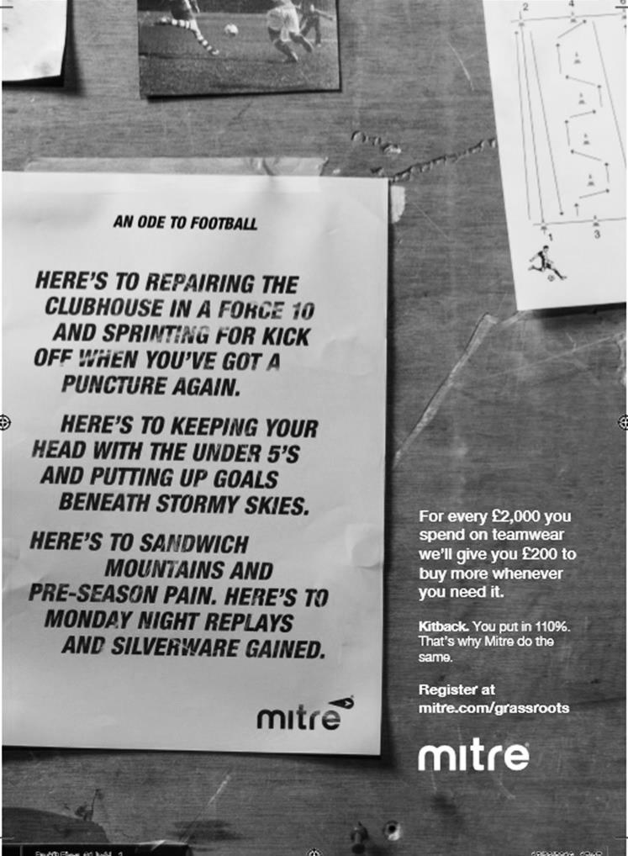

Surrey Senior Cup
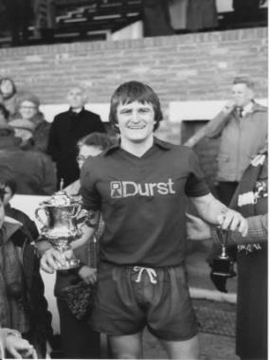
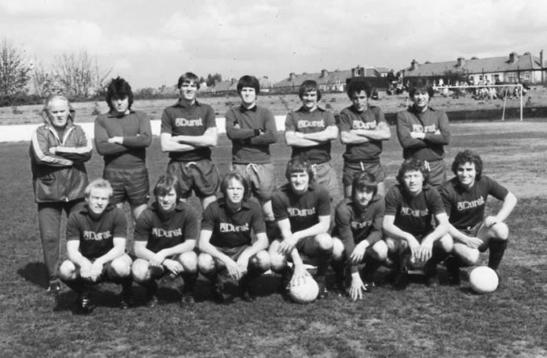
First Round
Abbey Rangers | 4-3 | AFC Croydon Athletic
Whyteleafe | 5-4 | Westfield
Second Round
Met Police | 15/11 | Kingstonian
Ashford Town (Mx) | 15/11 | Knaphill
Woking | 1/12 | Walton Casuals
Whyteleafe | 6/12 | Colliers Wood United
Guildford City | 30/11 | Horley Town
Egham Town | 15/11 | Corinthian Casuals
Godalming Town | 6/12 | Merstham
Molesey | 1/12 | Leatherhead
Raynes Park Vale | 6/12 | Sutton United
Sutton Common Rovers | 28/11 | Camberley Town
Dorking Wanderers | 6/12 | South Park
Badshot Lea | 29/11 | Farnham Town
Walton & Hersham | 1/12 | Croydon
Carshalton Athletic | 1/12 | Tooting & Mitcham United
Chertsey Town | 29/11 | Abbey Rangers
Epsom & Ewell | 6/12 | Chipstead



First Eleven Appearances 2016/17 - (max 21)
Name | Debut | 2016/17 |  |  |  | Career Totals
Name | Debut | App | Sub | Total | Goals | App | Sub | Total | Goals
CLARK-GLEAVE Charlie | 23/08/2016 | 1 | 2 | 3 | 0 | 1 | 2 | 3 | 0
COOPER-SMITH Daryl | 03/01/2015 | 16 | 1 | 17 | 15 | 46 | 9 | 55 | 35
DEAN Dan | 02/08/2014 | 13 | 2 | 15 | 0 | 81 | 6 | 87 | 2
EACOTT Michael | 02/08/2014 | 17 | 0 | 17 | 0 | 102 | 1 | 103 | 0
FARRELL Matt | 02/08/2014 | 20 | 0 | 20 | 10 | 106 | 4 | 110 | 28
FERDINANDO Matt | 20/09/2014 | 9 | 3 | 12 | 2 | 62 | 9 | 71 | 16
GALLAGHER Jordan | 07/08/2016 | 7 | 11 | 18 | 4 | 7 | 11 | 18 | 4
GRIFFIN Reisse | 08/08/2015 | 19 | 1 | 20 | 2 | 47 | 7 | 54 | 4
HASTINGS Craig | 08/08/2015 | 13 | 5 | 18 | 1 | 50 | 9 | 59 | 1
HEAGNEY Adam | 16/08/2016 | 13 | 2 | 15 | 0 | 13 | 2 | 15 | 0
HENDRY Rob | 08/08/2015 | 14 | 4 | 18 | 3 | 44 | 15 | 59 | 15
MCKAY Alex | 20/12/2008 | 13 | 2 | 15 | 2 | 121 | 32 | 153 | 10
NEALE Tom* | 13/10/2015 | 6 | 5 | 11 | 7 | 22 | 24 | 46 | 17
NORTH Rhys* | 16/08/2015 | 2 | 2 | 4 | 0 | 19 | 9 | 28 | 1
NWACHUKWU Jason | 01/10/2016 | 2 | 4 | 6 | 0 | 2 | 4 | 6 | 0
PANAYIOTOU Savvas | 03/01/2015 | 15 | 3 | 18 | 0 | 47 | 11 | 58 | 7
PRICE Matt* | 23/08/2016 | 2 | 0 | 2 | 1 | 2 | 0 | 2 | 1
ROBINSON Sam* | 22/10/2011 | 7 | 1 | 8 | 1 | 61 | 6 | 67 | 14
ROSE Daniel | 25/10/2016 | 1 | 1 | 2 | 0 | 1 | 1 | 2 | 0
SALEH Mennar* | 24/09/2016 | 0 | 2 | 2 | 0 | 0 | 2 | 2 | 0
SMITH Matt | 08/08/2009 | 0 | 1 | 1 | 1 | 91 | 44 | 135 | 11
TANTON Matt | 02/08/2014 | 17 | 1 | 18 | 1 | 74 | 5 | 79 | 3
TAYLOR James | 26/08/2013 | 16 | 2 | 18 | 0 | 102 | 14 | 116 | 6
THOMPSON Elliott | 09/02/2016 | 3 | 0 | 3 | 1 | 7 | 9 | 16 | 1
TURPIE Alistair | 31/03/2016 | 4 | 1 | 5 | 0 | 6 | 1 | 7 | 0
WATRET Jack* | 02/08/2016 | 1 | 0 | 1 | 0 | 1 | 0 | 1 | 0
* player has left the club

Every Opponent A-Z
Over the years we have played many, many different opponents. Exactly how many is a difficult question, as it all depends on your definition. Are Camberley & Yorktown different to Camberley Town, or are Epsom Town different to Epsom F.C. or Epsom & Ewell F.C.?

In my analysis I have classed both of the above examples as the same team, and will work through them all from A to Z. Some we have played many times, whilst others we have met just once or twice. Enjoy!
Swanley Town: Played 1 - W1 D0 L0 - F2 A0 - PPG - 3.00 - Perfect

We met Swanley Town just the once, back on 31st October 1981 for a London Senior Cup tie. They were a London Spartan League club and we were expected to win comfortably, especially as we were a very good side at the time, having beaten Southern League Thanet United (now Margate) 6-0 in the F.A. Trophy the week before. However, it took two late goals from Les Peck and Tommy Tuite before we were able to scrape through 2-0 in a match that had been switched to West Street. We would then defeat Welling United and Hendon before losing in extra time to the all-conquering Leytonstone / Ilford team that would win four trophies that season. For Swanley Town (no connection to Alma Swanley who were around back then) their time was short and they had disappeared forever within a few years.

Thame United: Played 5 - W1 D0 L4 - F1 A7 - PPG - 0.60 - Awful

Thame United joined the Isthmian League after moving up from the South Midlands League in 1991 as the Isthmians expanded its geographical umbrella. We visited the Windmill Ground on three occasions and never even scored there, losing 1-0, 2-0 and 3-0, the last of these being for an Isthmian League Cup tie. We shared the two home league matches, winning 1-0 on 14th January 1992, with Andy Webster scoring our one goal against them, but the following year they were promotion bound and beat us by the same score.

We never met again as they reached the Isthmian League Division One. They went down in 1998 but bounced back the following season, also reaching the Semi-Finals of the F.A. Vase that year and remained at a decent level until being moved to the Southern League in the 2004 reorganisations.

Trouble followed as they were evicted from the Windmill Ground during 2005/06. They finished the season at Aylesbury United’s Buckingham Road ground, being relegated to the Hellenic League at the same time but then Aylesbury themselves were evicted in 2006. Worse was to follow as Thame dropped into Step Six football in 2007 but good news was on the horizon as they were able to move into a new ground in 2011.

Now settled at their new venue they operate back at Step Five in the Hellenic League Premier Division where ironically Aylesbury United now ground share with them!

Thames Polytechnic: Held over to next issue

Three Bridges: Played 4 - W3 D0 L1 - F12 A6 - PPG - 2.25 - Fantastic

Maybe because we visited the Jubilee Field for a couple of heavy friendly defeats many years back I had this idea that we didn’t have a great record against the Crawley based Three Bridges. However, pre-season friendlies don’t count in the club records and our record is in fact a healthy one.

We first met on 30th August 1986 in the F.A. Cup at West Street. We had just been relegated from the Isthmian Premier Division and had designs on an immediate return, so expected to brush aside the little Sussex League club who were effectively two divisions below us. However, what we didn’t know was that this team would be Sussex League Champions that season and they beat us 2-1 that

day. They led at half time but when we equalised, through young defender Matt Elliott’s first ever goal for the club, I thought we would at least hold on for a replay. They had other ideas though and scored a late winner.

We would get revenge in some fashion back in November of 1988 as we met in an F.A. Vase Second Round match at West Street. Even then we trailed at the half, but a Neil Robson equaliser forced extra time where we ran riot; the match ending up 6-2 to us and we went on to reach the Fourth Round that season.

We didn’t meet for nine years until being paired together in the Vase once again, this time at Jubilee Field, where goals from Andy Boxall, former Epsom and Ewell Supporters F.C. player Nick Cawthorne and Steve Smith ensured a 3-1 win after being level at the break.

Since that time they have moved up to the Isthmian League and so by the time of our final meeting in the F.A. Cup on 26th August 2012, we were a division below them and yet again we went behind before a quite brilliant solo goal from Hong Moon lit the fuse. We played really well that day and Ben Hayward scored the winner in the second half to earn a lucrative tie at Bognor Regis Town.

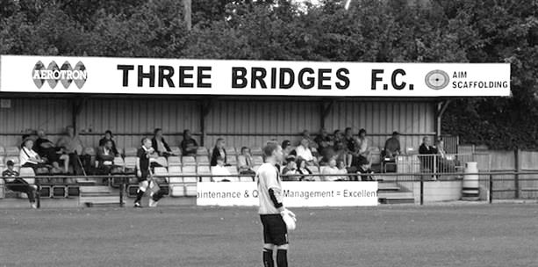
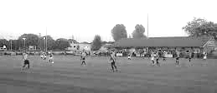
They have established themselves in the Ryman League South and remain there to this day.

Combined Counties League Premier Division Opponents
All-time Records
incl Tuesday 8th November | P | W | D | L | F | A | PPG | GD | Best  Win | Worst  Loss
Abbey Rangers | 2 | 2 | 0 | 0 | 8 | 1 | 3.00 | +7 | 7-1 | X
Bedfont & Feltham | 1 | 1 | 0 | 0 | 9 | 2 | 3.00 | +7 | 9-2 | X
Spelthorne Sports* | 5 | 4 | 1 | 0 | 15 | 6 | 2.60 | +9 | 6-2 | X
Sutton Common Rovers | 11 | 9 | 1 | 1 | 29 | 13 | 2.55 | +16 | 4-0 | 1-4
Horley Town | 29 | 20 | 5 | 4 | 65 | 30 | 2.24 | +35 | 6-0 | 1-3
Colliers Wood United | 22 | 14 | 2 | 6 | 45 | 33 | 2.00 | +12 | 4-0 | 0-5
Westfield | 19 | 11 | 3 | 5 | 40 | 31 | 1.89 | +9 | 6-1 | 0-4
Bedfont Sports | 9 | 5 | 2 | 2 | 13 | 10 | 1.89 | +3 | 3-0 | 0-4
Farnham Town | 14 | 8 | 2 | 4 | 25 | 23 | 1.86 | +2 | 3-1 | 1-4
Knaphill | 7 | 4 | 1 | 2 | 15 | 8 | 1.86 | +3 | 4-0 | 1-2
Guildford City | 17 | 10 | 1 | 6 | 34 | 22 | 1.82 | +12 | 5-1 | 1-5
Hanworth Villa | 15 | 8 | 3 | 4 | 38 | 26 | 1.80 | +12 | 5-0 | 1-4
Raynes Park Vale | 27 | 13 | 6 | 8 | 58 | 37 | 1.67 | +21 | 6-1 | 0-2
Badshot Lea | 18 | 8 | 3 | 7 | 35 | 34 | 1.67 | +1 | 4-1 | 0-4
Walton & Hersham | 50 | 24 | 10 | 16 | 101 | 97 | 1.64 | +4 | 6-0 | 0-8
Camberley Town* | 89 | 38 | 22 | 28 | 158 | 123 | 1.52 | +35 | 9-1 | 0-4
Hartley Wintney | 10 | 4 | 3 | 3 | 25 | 17 | 1.50 | +8 | 5-0 | 2-4
Windsor | 48 | 18 | 12 | 18 | 88 | 90 | 1.38 | -2 | 4-0 | 0-6
Chertsey Town | 47 | 17 | 5 | 25 | 70 | 86 | 1.19 | -16 | 3-0 | 0-7
AFC Hayes | 8 | 2 | 2 | 4 | 16 | 15 | 1.00 | +1 | 7-0 | 0-3
North Greenford United | 11 | 3 | 2 | 6 | 15 | 20 | 1.00 | -5 | 3-0 | 1-4
CB Hounslow United | 2 | 0 | 0 | 2 | 2 | 7 | 0.00 | -5 | X | 1-5
* includes one abandoned match v Camberley and one loss on penalties v Spelthorne

EL Records Premier Challenge Cup

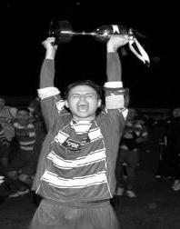
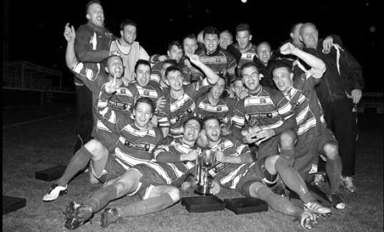
First Round
Redhill | 4-0 | Bedfont & Feltham
Match played at Bedfont & Feltham F.C.
Spelthorne Sports | 1-4 | Sutton Common Rovers
Knaphill | 0-2 | Camberley Town
Worcester Park | 2-1 | Dorking
Epsom & Ewell | 1-0 | Abbey Rangers
Westfield | 3-2 | North Greenford United
Cobham | 3-2+ | Bagshot
CB Hounslow United | 3-4 | Farnham Town
South Park Reserves | 1-4 | Balham
Second Round
Hanworth Villa | 2-4+ | Epsom and Ewell
AFC Hayes | 3-4 | Balham
Epsom Athletic | 1-5 | Windsor
Sutton Common Rovers | 21/11 | Bedfont Sports
Raynes Park Vale | 2-0 | Colliers Wood United
Frimley Green | 1-2 | Banstead Athletic
Westfield | 8-4+ | Redhill
Staines Lammas | 0-1 | Farnham Town
Worcester Park | 19/11 | Cove
Badshot Lea | 0-5 | Guildford City
Chertsey Town | 1-2 | Camberley Town
Cobham | 1-3 | Chessington & Hook United
Hartley Wintney | 4-0 | AC London
Horley Town | 2-2+ | Sheerwater
Horley Town won 5-4 on penalties
Walton & Hersham | 5-1 | Eversley & California
Ash United | 2-0 | Farleigh Rovers
Third Round
Banstead Athletic | 15/11 | Westfield
SCR / Bedfont Sports | V | Walton & Hersham
Farnham Town | 22/11 | Camberley Town
Ash United | 0-2 | Windsor
Raynes Park Vale | 2-1 | Hartley Wintney
Guildford City | 2-1 | Balham
Horley Town | 2-0 | Chessington & Hook United
Worcester Park / Cove | V | Epsom & Ewell

Player Sponsorship
Here is the current list for the 2016/17 season showing all of our players and Management that are currently available for sponsorship.

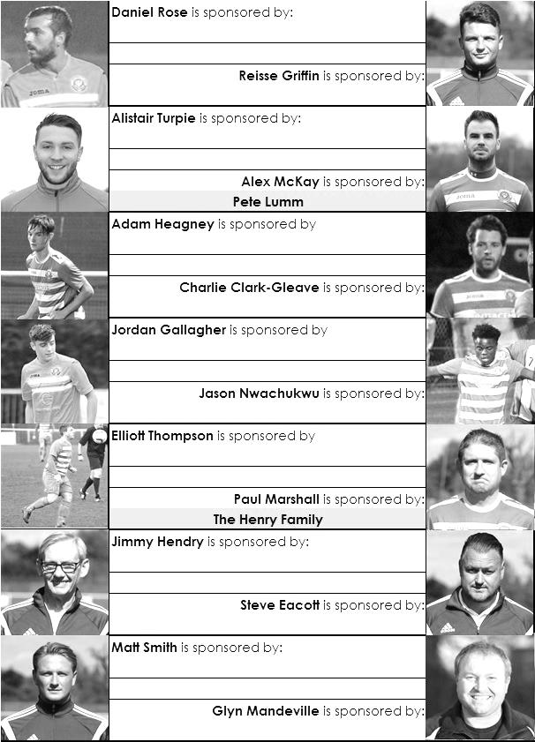

Sponsorship costs just £40 and it is easy to do. Just select a player who has not been previously sponsored and let a Committee Member know that you would like to sponsor them. Beware though. Until we have received the money it is possible for someone to jump in front of you, so don’t delay, sponsor today!
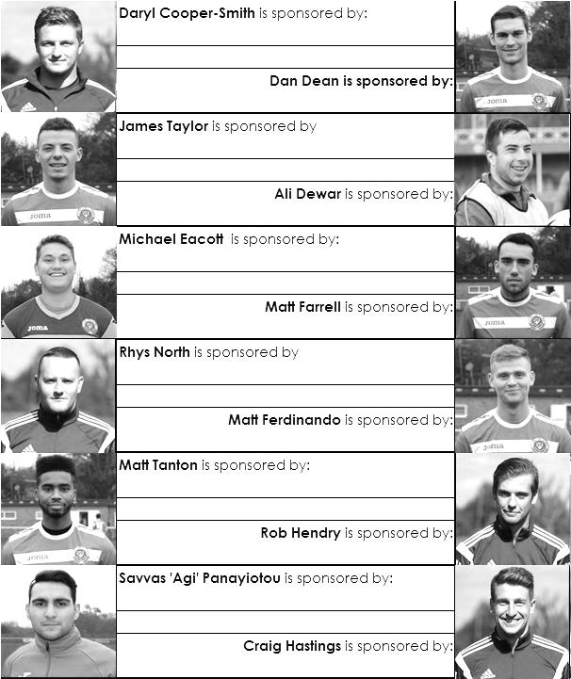

Match and Ball Sponsorships – 2016/17
Opponent | Date | Match Sponsor | Ball Sponsor
Gravesham Borough | 07/08/16 | Club President - Stella Lamont
Gravesham Borough | 07/08/16 | Relocation Committee Member - Mike Lovett
CB Hounslow United | 16/08/16 | EEFC Management Committee
Abbey Rangers | 23/08/16 | Steve & Geoff Dyke
Horley Town (11.30am) | 29/08/16 | In Memory of Chris Henry
Abbey Rangers (LC) | 06/09/16 | Paul Merritt
Camberley Town | 10/09/16 | Building Shop Ltd
Knaphill | 24/09/16 | EEFC Holding Company Director – Pete Lumm
Bridon Ropes (FAV) | 22/10/16 | George and Joseph Saunders
Sutton Common Rovers | 08/11/15 | Alex McKay Senior
Abbey Rangers (FAV) | 13/11/16 | EEFC Holding Company Director – Dave Ellins
Windsor | 15/11/16
Bedfont Sports | 19/11/16
AFC Hayes | 26/11/16
Chipstead (SSC) | 06/12/16
Hanworth Villa | 13/12/16
Chertsey Town | 17/12/16
Raynes Park Vale (11.30am) | 27/12/16
Spelthorne Sports | 07/01/17
Guildford City | 17/01/17
Bedfont & Feltham | 21/01/17 | Programme Editor - Richard Lambert
Badshot Lea | 04/02/17
Westfield | 18/02/17
Walton & Hersham | 04/03/17
Hartley Wintney | 18/03/17
Farnham Town | 25/03/17
Colliers Wood United (1pm) | 14/04/17 | Good Friday match – make a note!
North Greenford United | 22/04/17 | Club President - Stella Lamont
For League, League Cup and Surrey Senior Cup Matches:
Match sponsorship - £40.00 Match ball sponsorship - £25.00. Combined £55.00.
For F.A. Cup and F.A. Vase matches:
Match sponsorship - £50.00 Match ball sponsorship - £30.00. Combined £65.00.

Sponsorship includes: (x2 for match, x3 for match and ball)

Admission, programmes, hospitality and advertising and mascot for the day (if required).
If you are interested, just speak to a Committee Member, or drop me an email at: richard.c.lambert@gmail.com


We also thank our Kit Sponsors INTERCEM

Salts Super Six Predictor
The Salts Super Six Predictor is live again for today’s match and the tickets are on sale at today’s game to the left of the gate. Please note that the fixtures are to be played on Tuesday evening.

The competition is easy to play! To win, you simply need to predict the results of six matches correctly from the three options, fill in the form and make sure it is back with our seller before the deadline on the ticket. The latest fixtures are shown below.

If you are a club regular, you just need to place your name on the sheet, although if you aren’t, then we’ll need a contact number from you too. We will announce any winners on the website within three working days, so don’t worry, we won’t miss you!

We had a big jackpot winner last year and it is now very large again! It is currently £305 and you’ll always know the size of the pot before you enter.

Please note that if there is more than one winner, the prize pot would be shared between the winners. All you need to do now is have a go, as many times as you like!

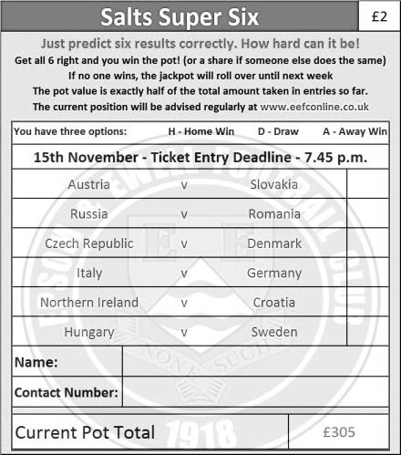

Good luck!

Buildbase F.A. Vase – Second Round
Sunday, 13th November 2016 - Kick-off 3.00 p.m.



Epsom and Ewell  (Royal Blue & White hoops) | V |  | Abbey Rangers  (Black & White Stripes)
Squad | NUMBERS
Michael Eacott |  |  | Liam Stone
Adam Heagney |  |  | Jason Macgregor
Matt Tanton |  |  | George Davies
© Dan Dean |  |  | James Shannon
James Taylor |  |  | Dale Webb
Alex McKay |  |  | Tom Bentley
Reisse Griffin |  |  | Joe Macklin
Matt Farrell |  |  | Marcus Aristide
Daryl Cooper-Smith |  |  | Tom Arnold
Matt Ferdinando |  |  | Nick Ford
Jordan Gallagher |  |  | Ben Kersley
Savvas ‘Agi’ Panayiotou |  |  | Sam Workman
Craig Hastings |  |  | Jason Robertson
Jason Nwachukwu |  |  | Luke Robertson
Daniel Rose |  |  | Joe Paris
Charlie Clark-Gleave |  |  | Elliott Firth
Alistair Turpie |  |  | Michael Carey
Rob Hendry |  |  | Danny Hartlebury
Matt Smith |  |  | Paul Hodges
 |  |  | Alex Hendrie
Glyn Mandeville | MANAGER |  | Mike Woolgar
Matt Smith | ASSISTANT |  | Paul Johnson
Steve Eacott / Alex McKay / Jimmy Hendry | COACHES / PHYSIO |  | Dale Webb
REFEREE: T.Dowdeswell
ASSISTANTS: P.Maskell, W.Ingram
Today’s Match and Match Ball are sponsored by Club Director and former Chairman Dave Ellins

Combined Counties League – Premier Division
Tuesday, 15th November 2016 - Kick-off 7.45 p.m.
Epsom and Ewell  (Royal Blue & White hoops) | V |  | Windsor  (Green & Red, Green, Green)
Squad | NUMBERS
Michael Eacott |  |  | Hugo Sobte
Adam Heagney |  |  | Dean Aldred
Matt Tanton |  |  | Denzel Bonilla-Hurtado
© Dan Dean |  |  | Gus Bowles
James Taylor |  |  | Luke Brooks-Smith
Alex McKay |  |  | Riccardo Cannon
Reisse Griffin |  |  | Connor Channon
Matt Farrell |  |  | Jamie Di Guiseppe
Daryl Cooper-Smith |  |  | Barry Dunbar
Matt Ferdinando |  |  | Mitchell Evans
Jordan Gallagher |  |  | Emmanoyil Goganos
Savvas ‘Agi’ Panayiotou |  |  | Travis Hodge
Craig Hastings |  |  | Andrew Ingram
Jason Nwachukwu |  |  | Baboucar Jarra
Daniel Rose |  |  | Amin Khomsi
Charlie Clark-Gleave |  |  | Keiran Knight
Alistair Turpie |  |  | Jamel Laazizi
Rob Hendry |  |  | Henry Montague
Matt Smith |  |  | Henry Poole
Glyn Mandeville | MANAGER |  | Mick Woodham
Matt Smith | ASSISTANT |  | Ashley Smith
Steve Eacott / Alex McKay / Jimmy Hendry | COACHES / PHYSIO |  | Simone Connor
REFEREE: D.Wynter
ASSISTANTS: P.Maskell, R.Wells

OUR NEXT VISITORS TO HIGH ROAD
Bedfont Sports

Combined Counties League – Premier Division
Saturday 19th November 2016 – 3.00 p.m.

